The Tragedy of Flight: A Comprehensive crash analysis

**A PROJECT REPORT**

**SUBMITTED BY**

|  |  |
| --- | --- |
| **L. SOMESHVARAN** | **222000937** |
| **K. S. PRAGHADEESHWARAN** | **222000936** |
| **R. MANIKANDAN** | **222000935** |
| **T. A. TAMILSELVAN** | **222000938** |
| **R. YUVARAJ** | **222OOO939** |

|  |  |  |
| --- | --- | --- |
| **CHAPTER NO** | **TOPIC** | **PAGE NO** |
| **1** | **Introduction** |  |
| **2** | **Problem Defining & Design Thinking** |  |
| **3** | **Data collection & extraction from Database in MYSQL** |  |
| **4** | **Introduction to Tableau** |  |
| **5** | **Connecting Database and Tableau** |  |
| **6** | **Data Visualization** |  |
| **7** | **Dashboard and stories** |  |
| **8** | **Web Integration** |  |
| **9** | **Advantages and Disadvantages** |  |
| **10** | **Conclusion & future Scope** |  |
|  |  |  |

**INTRODUCTION**

An airplane crash analysis is a detailed investigation into the causes of an aviation accident. The goal of an airplane crash analysis is to identify any factors that contributed to the accident, with the ultimate goal of improving safety and preventing future accidents. The process of conducting an airplane crash analysis typically involves the collection and analysis of a wide range of data, including information about the aircraft and its systems, the operators, and any other relevant factors. This data is typically collected from Kaggle. Once the data has been collected, it is analysed through tableau, to identify any potential causes of the accident. The results of an airplane crash analysis are typically published in a report, which may include recommendations for improving safety and preventing similar accidents in the future. These recommendations may be implemented by the relevant authorities or industry organizations.

**PROBLEM DEFINITION AND DESIGN THINKING**

# EMPATHY MAP

• An Empathy Map is a tool used to help understand and empathize with the perspective of a particular user or customer. It is a visual representation of the user's attitudes, behaviors, emotions, and experiences that can be used to gain a deeper understanding of their needs and motivations. The Empathy Map is typically divided into four quadrants: "Says," "Thinks," "Does," and "Feels." In each quadrant, the user's thoughts, feelings, actions, and spoken words are recorded to help build a more complete understanding of their perspective. The Empathy Map is often used in design thinking and user experience research to help inform the design of products or services that better meet the users

Empathy map

screenshot: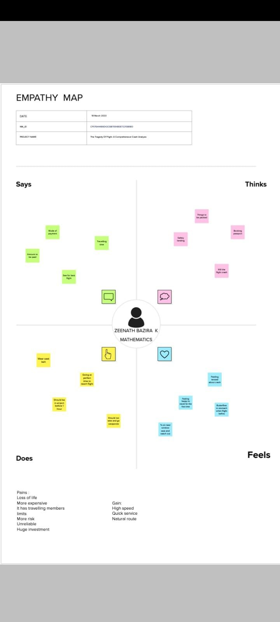

IDEATION AND BRAINSTORMING

Ideation and Brainstorming Maps are tools used to generate and organize ideas in a structured and visual way. They are commonly used in creative problem solving, innovation, and product design to generate a large number of ideas and then organize them into meaningful categories. • Ideation and Brainstorming Maps typically start with a central theme or problem statement in the center of the map. From there, branches are drawn out to represent different categories or subtopics related to the central theme. These categories can then be further expanded with additional branches to represent specific ideas. • The purpose of an Ideation and Brainstorming Map i is to encourage free thinking and generate as many ideas as possible. It allows participants to visually see how ideas are connected and to build upon each other's ideas. The map can then be used to prioritize and refine the most promising ideas. There are many variations of Ideation and Brainstorming Maps, including Mind Map.

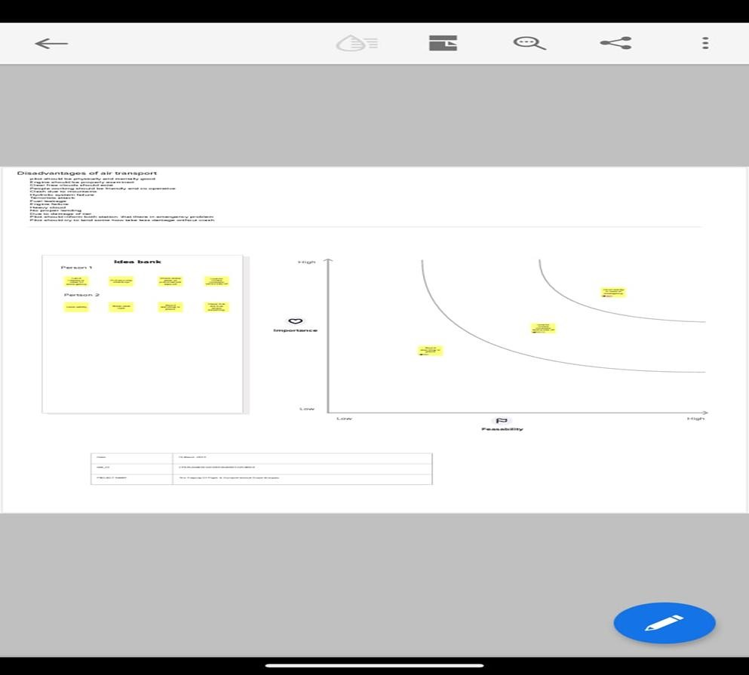

RESULTS:

OUT PUT SCREENSHOT

# SHEET1

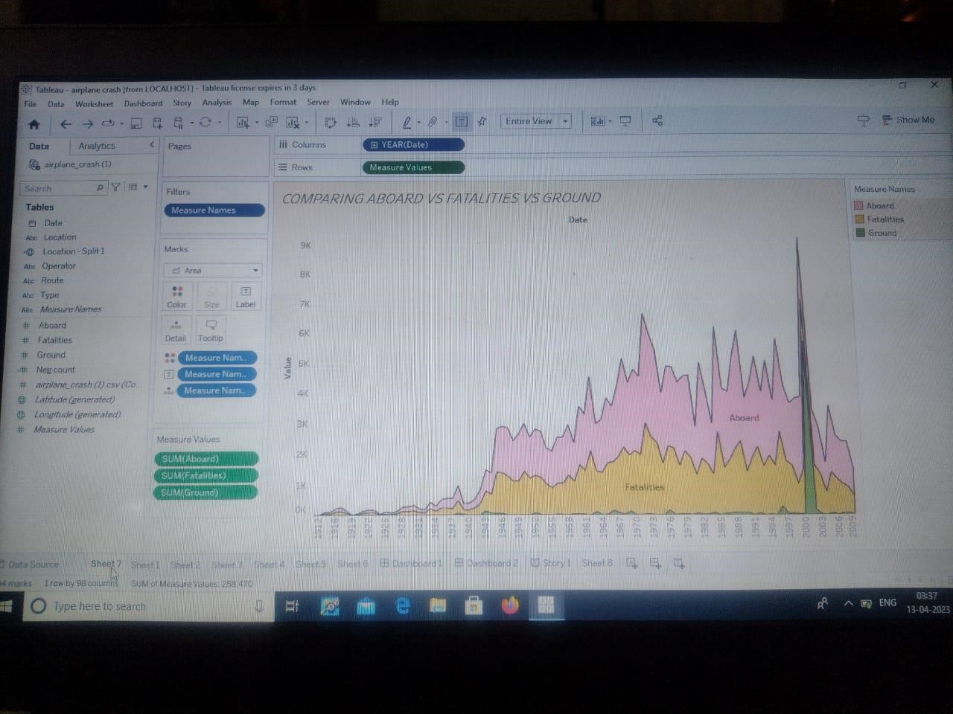

SHEET2

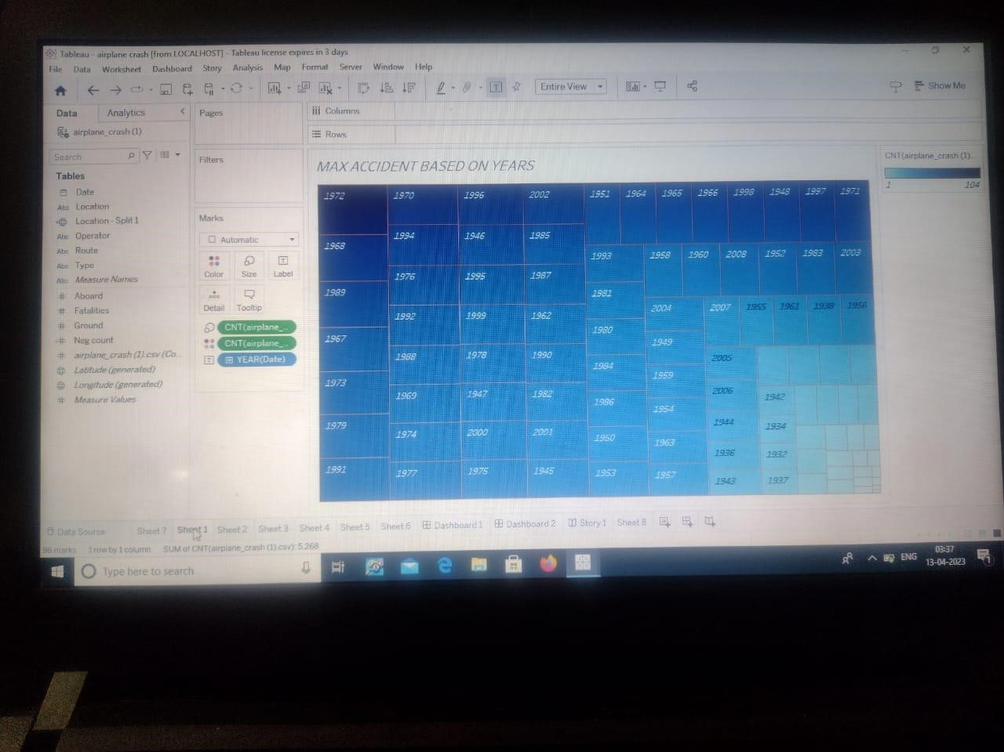

SHEET3

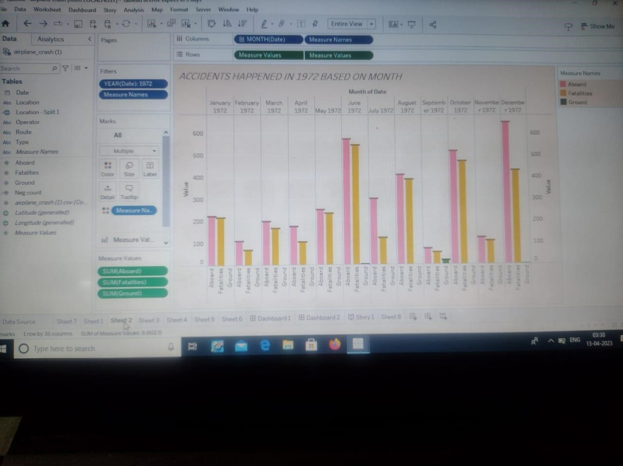

# SHEET4

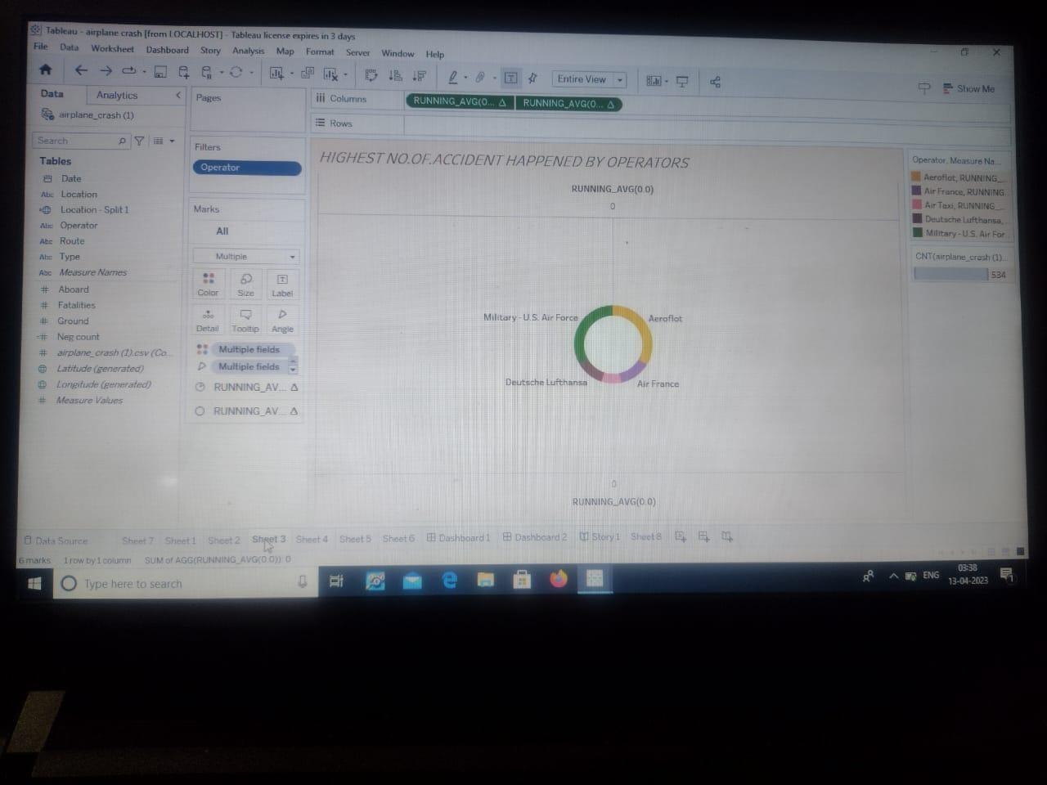

# SHEET 5

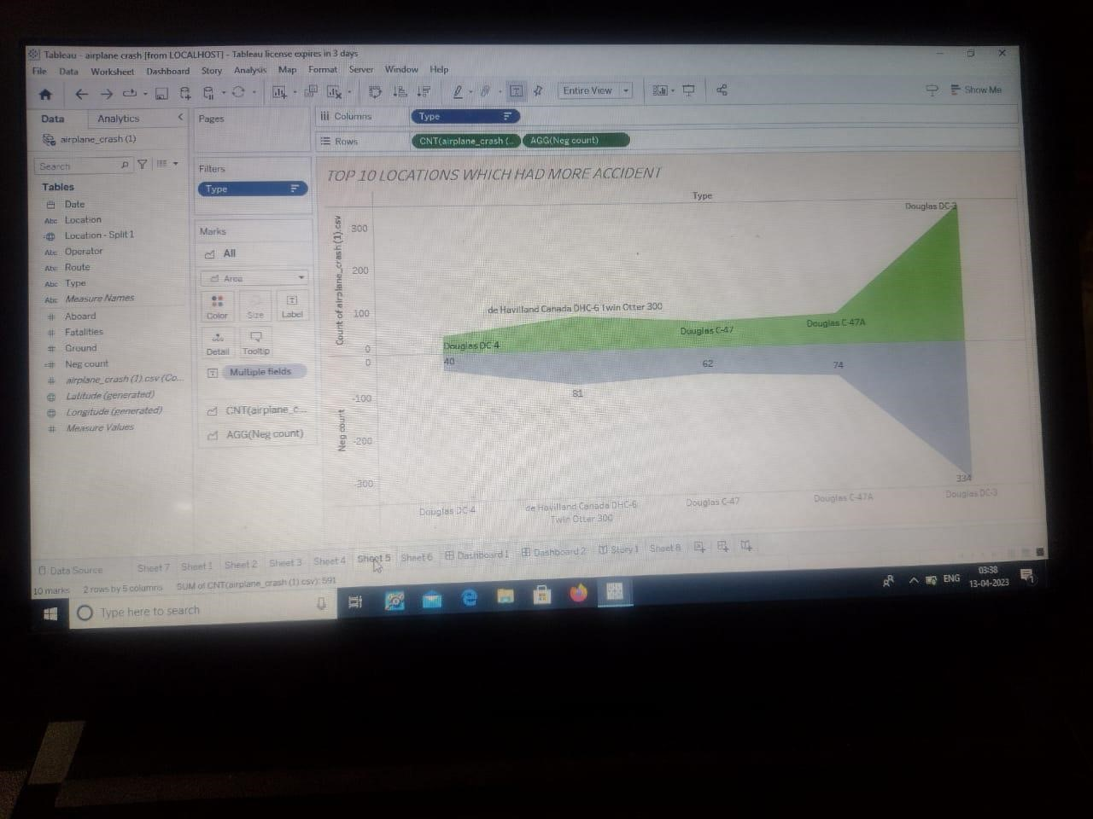

# SHEET6

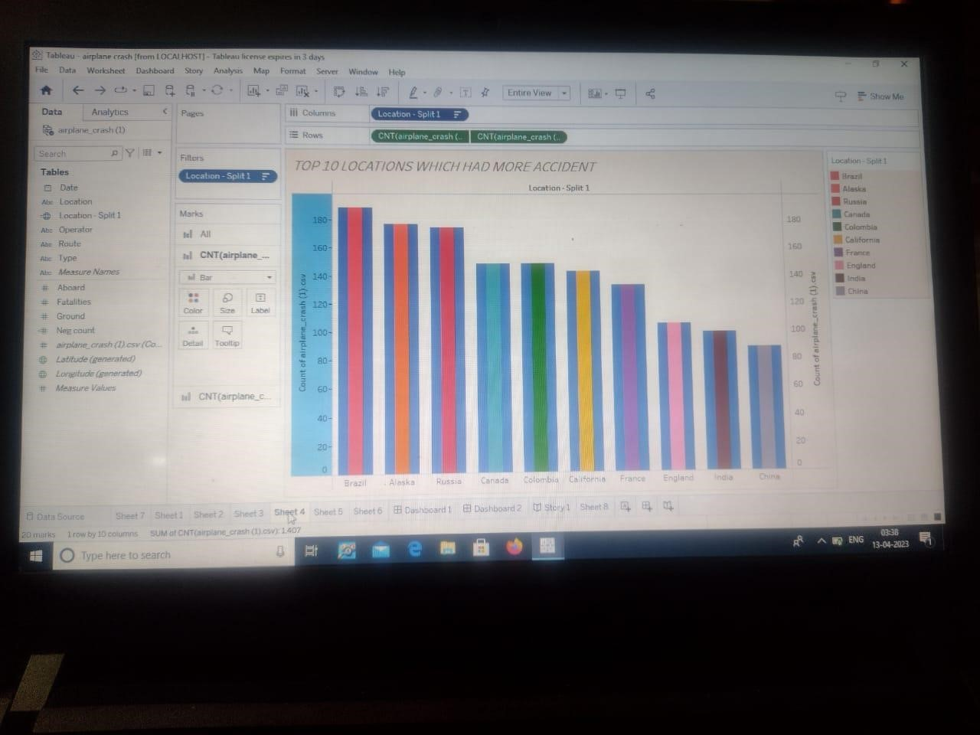

# SHEET 7

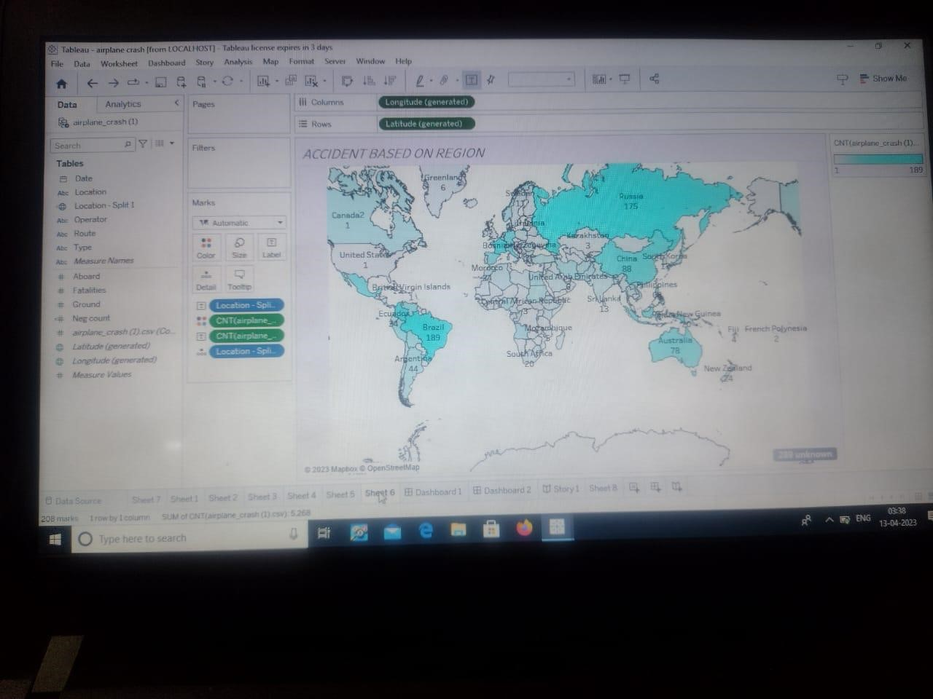

# DASHBOARD 1

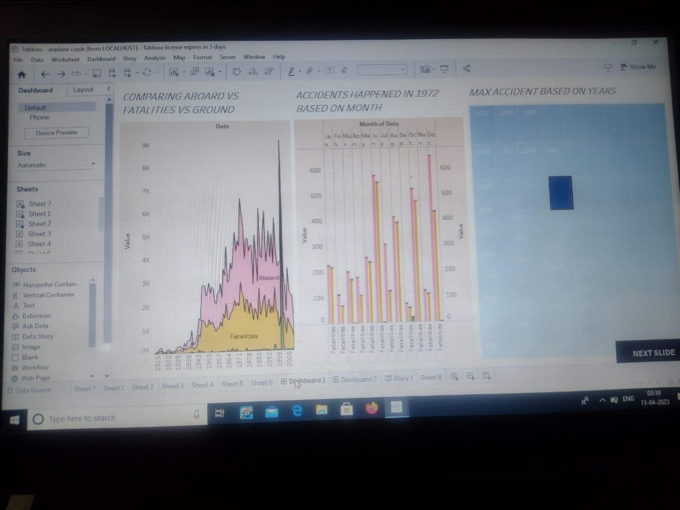

# DASHBOARD 2

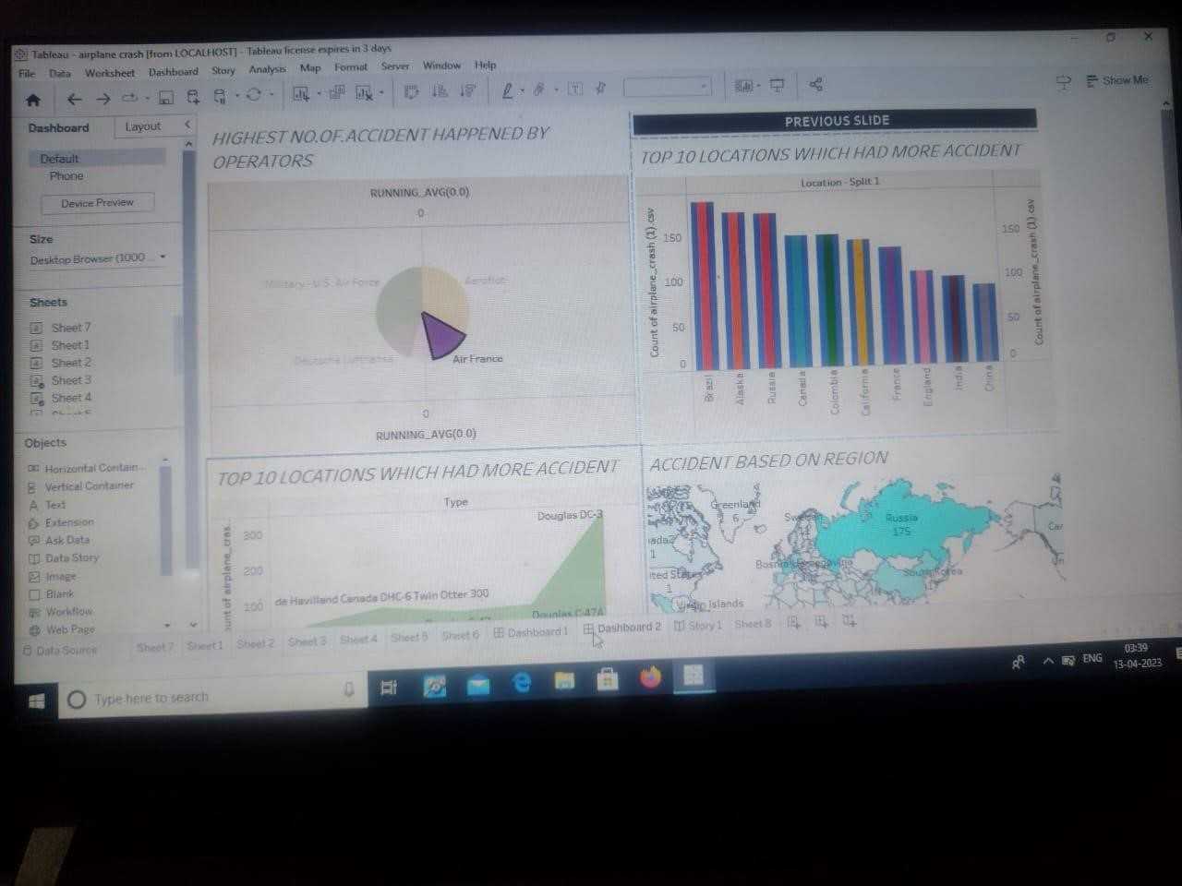

# STORY

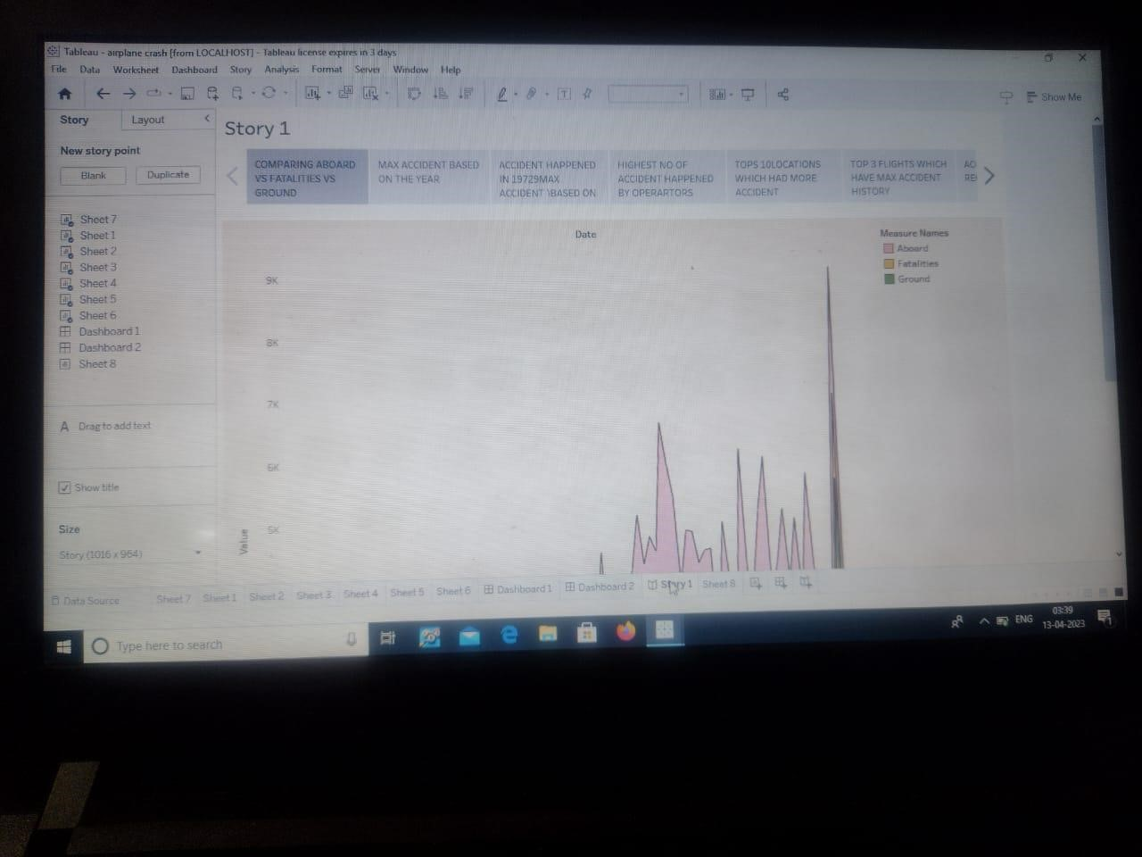

# **ADVANTAGES**

**HIGH SPEED**

**QUICK ACCESS**

**NATURAL ROUTE**

# **DISADVANTAGES**

**PILOT SHOULD BE PHYSICALLY AND MENTALLY GOOD**

**ENGINE SHOULD BE PROPERLY EXAMINED**

**OPERTORS SHOULD BE IN PROPER**

**ENGINE FAILURE**

## APPLICATIONS

**These can include the analysis of airplane’s performance, flight path, systems health, or pilot inputs. However, with increased amounts of data, it may not always be possible to transmit all of this data to the investigators in real time. The most versatile way would be the use of satellites, but the transmission speeds and volumes limited. The more data is being sent the more it costs, which operators are not always willing to pay the price for. Flight Data Recorders (FDRs) gather thousands of points of information every second, and not only live transmission would be costly, but the equipment required to perform this operation would cost a lot as well. [4] How the industry could make use of real-time Big Data analysis is to develop a system transmitting information only when certain parameter would be exceeded, for example in emergency situation. At that time, the aircraft would be able to send all the data from a certain time period and it would be ready for further analysis. At all other times, only certain limited data would be transmitted at longer intervals. This would also prevent not having access to the FDRs because they were lost in the accident and not found yet. This implementation of SRBD would require air safety investigators to categorize very specifically at what points the receiver would send all of the information. A thorough consideration of accident database would have to be performed to develop a structured way to categorize those parameters. While it is relatively easy to gather Big Data from airplane systems and components, it is crucial to remember that approximately 80% of accidents is caused by human error. [5] Human factors are what aviation industry is placing focus on, and the data analysis in this area cannot be performed that easily. However, as the safety science suggests, almost all human factors can be traced to the managerial side of the organization. [6] It is also being suggested that aviation Big Data analysis should make use of multilayer network correlation. [7] Therefore, Big Data analysis can be performed on many layers that are for example aircraft and its performance, or the management of the organization. Then correlations can be found between different layers and conclusions can be drawn. For example, any changes to the operator’s policy, any maintenance action, or any other trackable information could be assigned to particular aircraft’s systems or flight path that it is affecting. Whenever there is any issue in the future with parameters in the systems or flight path, the causing action that finds its source in management of the organization will be easily tracked and identified. Such network of connections is not something all air safety investigators have worked with before. Technological developments will pose a need for a new type of investigative techniques. [8] Data-drivenand riskthe risk for based approaches have to be taken into consideration to continuously decrease accidents or incidents. There is no time to wait for safety improvements, and the priority is to deve preventive actions. lop Air safety and accident investigators will also need to be able to analyse.**

**CONCLUSION**

**The most prominent finding is that crashes and fatalities have decreased while the number of passengers has increased. Furthermore, patterns on each different variable, such as location, operator, and phase of flight, provide us with deeper insights into the airplane crash patterns.**

**The main objective of this project is to raise awareness of flight safety and better understand its problems and progress, so that aviation industries can continue to improve. We hope that more information and understanding will lead to industry changes that save lives.**

# **FUTURESCOPE**

Tableau, a data visualization is one of the most demanded tools in today’s competitive IT world. Unsurprisingly, as the world is becoming more datacentric, the demand for Tableau developers has increased manifolds. Surprisingly enough, even small startups are offering a decent salary to hire skilled candidates. Apart from high pay, there are multiple reasons one should learn tableau.

In this post, we will find more about Tableau developer salary in India and why you might want to get certified in Tableau

There are several job roles that a Tableau developer is well-suited for. Here is a list:

Data Analyst

Business Analyst

Tableau Consultant

Business Intelligence Developer and Manager

With 90% of world’s data being stored digitally, the need for data visualization experts has risen manifolds. This is the best time to gain some expertise in this field and brighten your future! Learn more about how to become a tableau

developer..

of experiences This growth in tableau developer salary is attributable to technology that is growing at a rapid pace. Technology has led to life becoming all the easier than it was, say, a decade back. Tableau software has revolutionized the way things work in the software domain. Tableau Software is a form of interactive data software from America that helps in working on business intelligence. Tableau community of developers alone is a collation of a million members. This spans 500-plus user groups globally as well as Community Forums plus programs. It is highly active, diverse, innovative, and highly supportive and the latest online and offline practices.

**APPENDIX**